

Dear Friends, I wanted to give you the opportunity to participate in a Prison Ministry with me called [Kairos](http://kpmifoundation.org/index.php).  You can participate in several ways, through prayer and through baking cookies!  Yes, it’s that simple and powerful. You can never imagine the impact a little prayer and lots of cookies can have on the inmates (residents) at the [Northeast Correctional Complex](http://teams/sites/ts1517/Forms/Forms/AllItems.aspx).

Kairos is a Christian Ministry that has amazing success at impacting lives within the prison system for Christ through hosting a 4-day Christian Retreat.   Of the residents that have been through Kairos, the number that return to prison after getting out is more than CUT IN HALF.   The program has been so successful, many states try to have a group in each prison.  One of the treats for the residents is an endless supply of cookies during the weekend.   In fact, each Ministry Team Member needs to contribute 80 dozen cookies for the event, and I doubt I can cook that many on my own!   There will be 40+ residents participating in the program, but on Saturday night, each and every man in the prison complex will receive a dozen cookies.   You would be surprised how many men get choked up receiving these cookies.  **They do make a difference!**   Hence my offer to you for your help and participation in this ministry.   If you can bake some cookies I would be so appreciative and thrilled (sorry we cannot use store-bought cookies)!

**Baking Guidelines:**

**Warning:** There are restrictions as the inmates can make alcohol from about anything (in less than a day) so please if you help follow these guidelines.

We are going to be at the prison __________so I’ll need the cookies at the latest by _______________.   I will leave a box in my office where you can drop them off,  or email,  or call me and I will gladly come pick them up from you.  My numbers are 423-xxx-xxxx. I have a nice big deep freezer so I can easily store them.

Do’s and Don’ts for Cookies

•             **No Fruit, no nuts, no candy except chocolate chips**

•             No sugar or frosting on top

Types:

•             Sugar.

•             Molasses.

•             Peanut butter.

•             Chocolate chip.

•             Oatmeal (no raisins) .

•             **Please send them 12 in a bag, in a “roll” (like Ritz crackers)in a gallon size plastic bag (taping the end of the bag works well) – this makes sure they don’t get to the prison as just crumbs.**

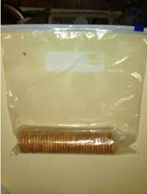 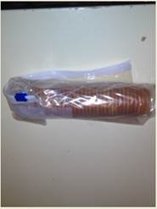

•             Please do not write on the bags with any sort of messages.

•             Please pray that God will use your cookies to demonstrate His love for the prisoners, guards, and staff that will receive them.

Thank you for considering to help with this ministry, I can promise you that it will change lives.

If you are further interested in this ministry please let me know because you can also serve during the weekend as a cook providing food for the team and the inmates. The cooking takes place at a local church. You can also join the weekend by attending the closing ceremonies where the inmates share their experience over the four days.  Just let me know if you have more interest.

If you know others that would like to help, please forward this on!!!!!!!!!!!!